

**Project Report**

**on**

**Influencer Website**

Submitted to

**LOVELY PROFESSIONAL UNIVERSITY**

for

**INT 220SERVER SIDE SCRIPTING**

**SubmittedBy Submitted to**

**Pragya Kumari Navneet Kaur**

**11914054 Assistant Professor**

**LOVELY FACULTY OF TECHNOLOGY & SCIENCES**

**LOVELY PROFESSIONAL UNIVERSITY**

**PUNJAB**

**April 2022**

**Table of Contents**

**Chapter Particulars Page No.**

1. Introduction……………………………………………………………... 2
2. Technologies used………………………………………………………. 3
3. Modules………………………………………………………................. 6
4. Website snapshots………………………………………………………. 7
5. GitHub link………………………........................................................... 13

References…………………………………………………………………………… 14

**CHAPTER 1**

**INTRODUCTION**

* 1. **Introduction**

**1.1.1 What is Server-Side Scripting?**

Server-side scripting as it relates to web pages usually refers to PHP code that is executed on the web server before the data is passed to the user's browser. In the case of PHP, all PHP code is executed server-side and no PHP code ever reaches the user. After the PHP code is executed, the information it outputs is embedded in the HTML, which is sent to the viewer's web browser. One way to see this in action is to open one of your PHP pages in a web browser and then choose the "'View Source" option. You see the HTML, but no PHP code. The result of the PHP code is there because it is embedded in the HTML on the server before the web page is delivered to the browser.

**1.2 What is PHP?**

PHP is a server-side scripting language that is embedded in HTML. It is used to manage dynamic content, databases, session tracking, even build entire e-commerce sites. It is integrated with a number of popular databases, including MySQL, PostgreSQL, Oracle, Sybase, Informix, and Microsoft SQL Server.

**1.2.1 Features of PHP**

PHP script is executed much faster than those scripts which are written in other languages such as JSP and ASP. PHP uses its own memory, so the server workload and loading time is automatically reduced, which results in faster processing speed and better performance.PHP source code and software are freely available on the web. You can develop all the versions of PHP according to your requirement without paying any cost. All its components are free to download and use.PHP is available for WINDOWS, MAC, LINUX & UNIX operating system. A PHP application developed in one OS can be easily executed in other OS also.PHP is a secure language to develop the website. It consists of multiple layers of security to prevent threads and malicious attacks.

**CHAPTER 2**

**TECHNOLOGIES USED**

**2.1 Name of Technologies Used**

**2.1.1PHP**

PHP is a server-side scripting language that is embedded in HTML. It is used to manage dynamic content, databases, session tracking, even build entire e-commerce sites. It is integrated with a number of popular databases, including MySQL, PostgreSQL, Oracle, Sybase, Informix, and Microsoft SQL Server.

**2.1.2 FontAwesome**

Font Awesome is the Internet's icon library and toolkit, used by millions of designers, developers, and content creators. Font Awesome 6 contains over 7,000 new icons, so you're sure to find what you need for your project. Plus, we've redesigned most of our icons from scratch, so they're more consistent and easier to use.Less time wrestling browser rendering.

**2.1.3 XAMPP**

XMPP is a short form for Extensible Messaging Presence Protocol. It's protocol for streaming XML elements over a network in order to exchange messages and presence information in close to real time. This protocol is mostly used by instant messaging applications like WhatsApp.

**2.1.4 HTML**

HTML (HyperText Markup Language) is the code that is used to structure a web page and its content. For example, content could be structured within a set of paragraphs, a list of bulleted points, or using images and data tables.

**2.1.5 CSS**

CSS, or “Cascading Style Sheets,” is used for styling and laying out webpages. It can be used to adjust content size, spacing, color and font or add decorative features, such as animations or split content into columns.

**2.1.6 JavaScript**

JavaScript is a single-threaded programming language, which means it has a single Call Stack. Therefore, it can do one thing at a time. The Call Stack is a data structure which records basically where in the program we are. If we step into a function, we put it on the top of the stack.The way it works is interesting. Inside a normal Web page, you place some JavaScript code. When the browser loads the page, the browser has a built-in interpreter that reads the JavaScript code it finds in the page and runs it.

**2.1.7 Bootstrap**

Bootstrap is a potent front-end framework used to create modern websites and web apps. It's open-source and free to use, yet features numerous HTML and CSS templates for UI interface elements such as buttons and forms. Bootstrap also supports JavaScript extensions.

**2.2Websites used for UI Icons/Images**

**2.2.1Pexels**

Pexels is a free stock photo and video website and app that helps designers, bloggers, and everyone who is looking for visuals to find great photos and videos that can be downloaded and used for free. If you see a photo or video you like, simply download it for free.

**CHAPTER 3**

**MODULES**

**3.1 Directory Structure**

**3.1.1Database Module**

With PHP, we can connect to and manipulate databases. MySQL is the most popular database system used with PHP. In this project I have used MySQL with XAMPP.There is a Database Config File in the Includes directory which is solely responsible for the database changes and connectivity. It includes many important variables like hostname, username, password, conn and database.

**3.1.2 Front-End Module**

I have used HTML, CSS, and JavaScript for the Front-End. All the Files are segregated into different files for easy readability.

**3.1.3 PHP files**

I have total of 18 PHP files segregated properly for better understandability and readability purpose. The PHP files for normal users who visit to read (readers who visit page to read technical blogs) are kept in root directory. The files are as follows: Category, contact, index, login, logout, register,single. The Reader can easily visit and click on any category and read the blogs by clicking on the topics. The PHP files for the Author/Admin are kept segregated in the admin folder. The admin folder has various other files such as CSS, IMG, INCLUDES, JS, SCSS, UPLOADS and VENDORS.

The admin file has PHP files like add-category, add-post, blank, categories, delete-category, edit-post, index, posts and tables

**CHAPTER 4**

**WEBSITE SNAPSHOTS**

**4.1 Overview of Website**

**4.1.1 XAMPP**

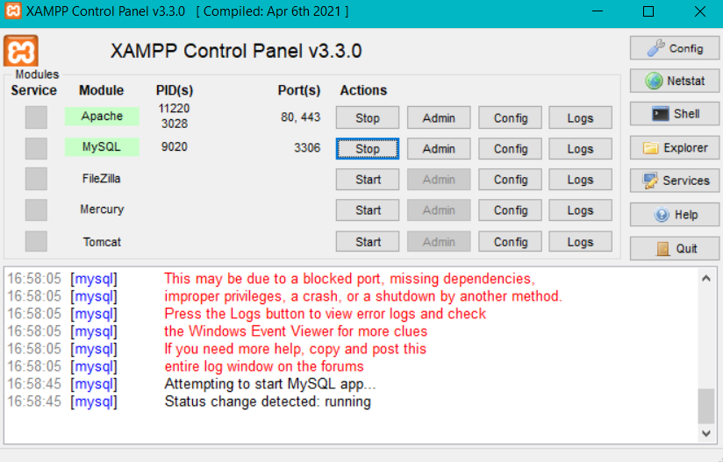

**Figure 4.1 Dashboard**

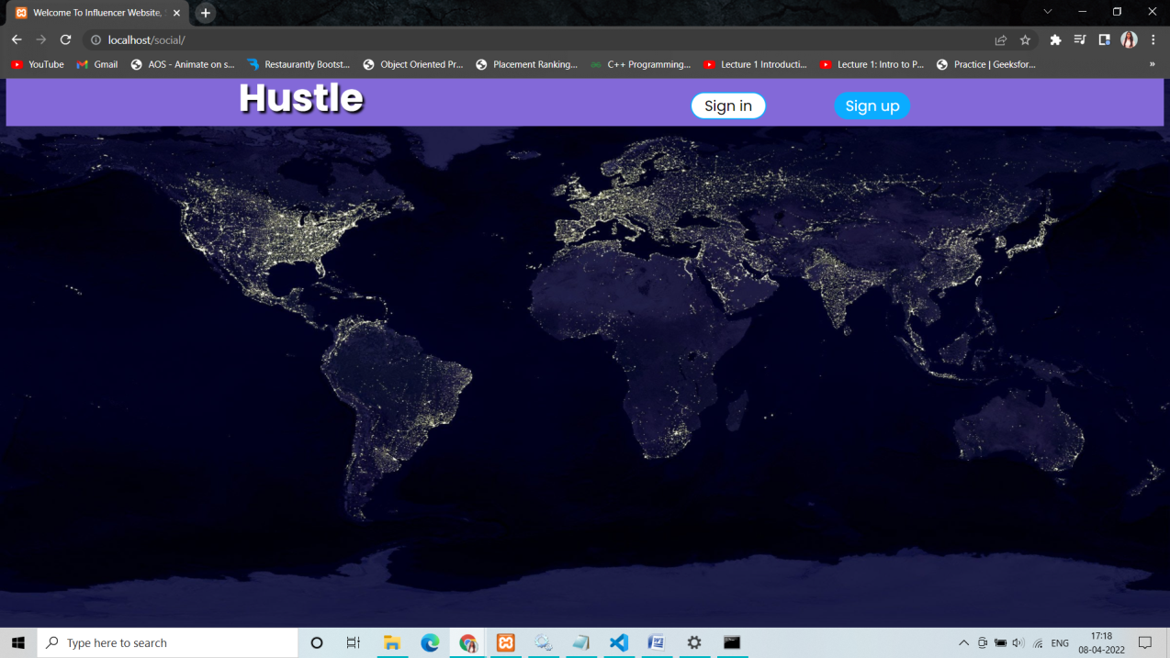

**4.2 Sign Up Page**

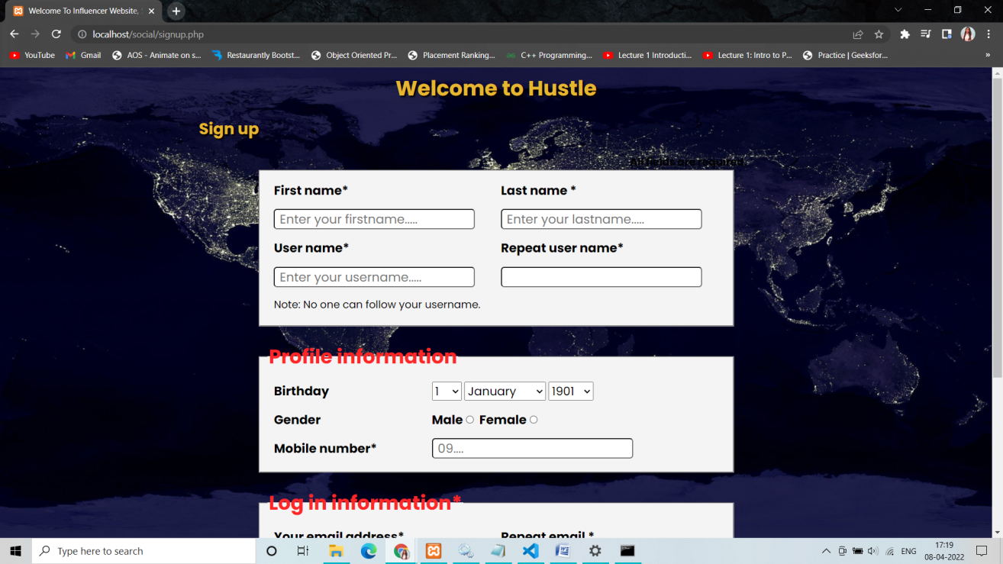

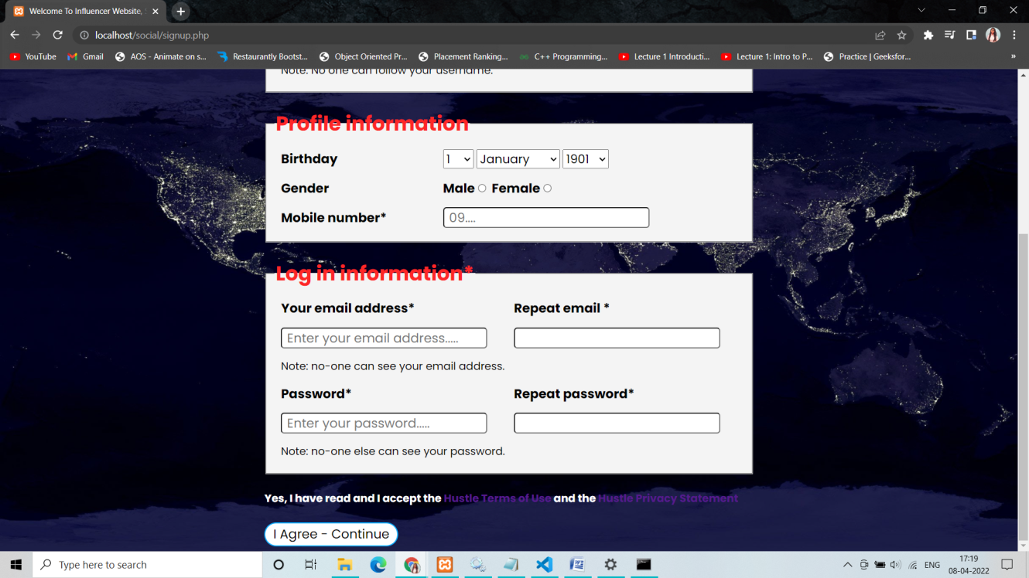

**4.3 Sign In Page**

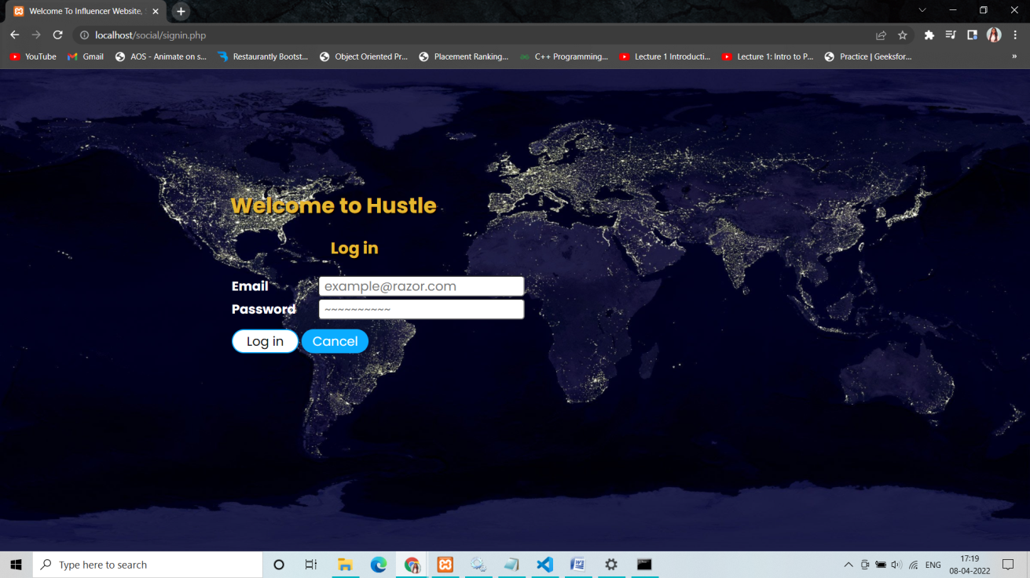

**4.4 Home Page**

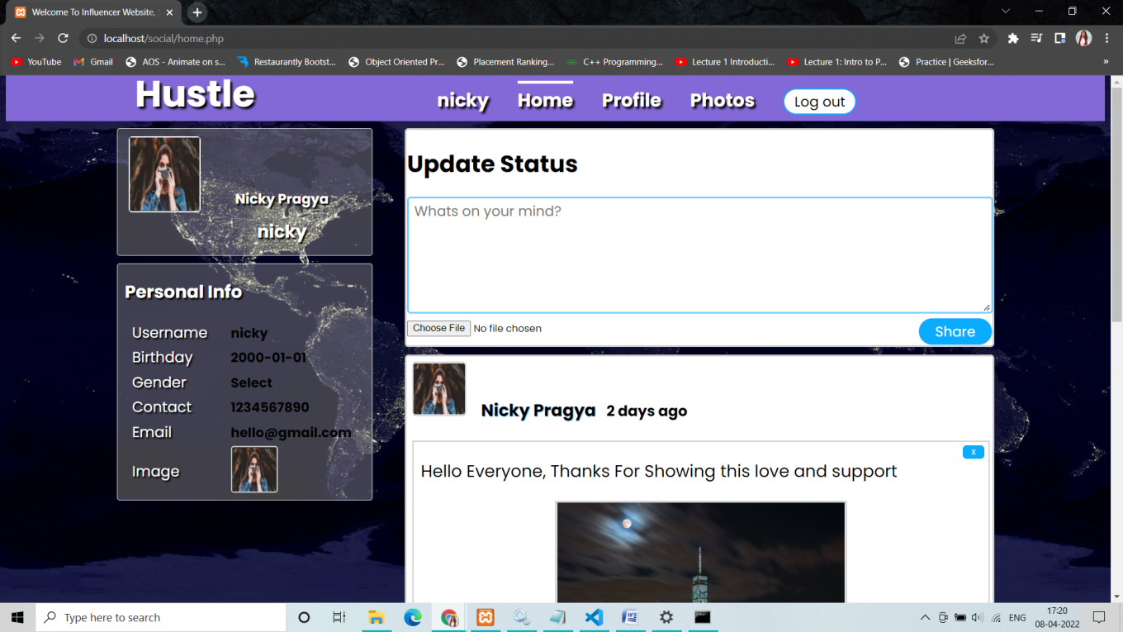

**4.5 Timeline**

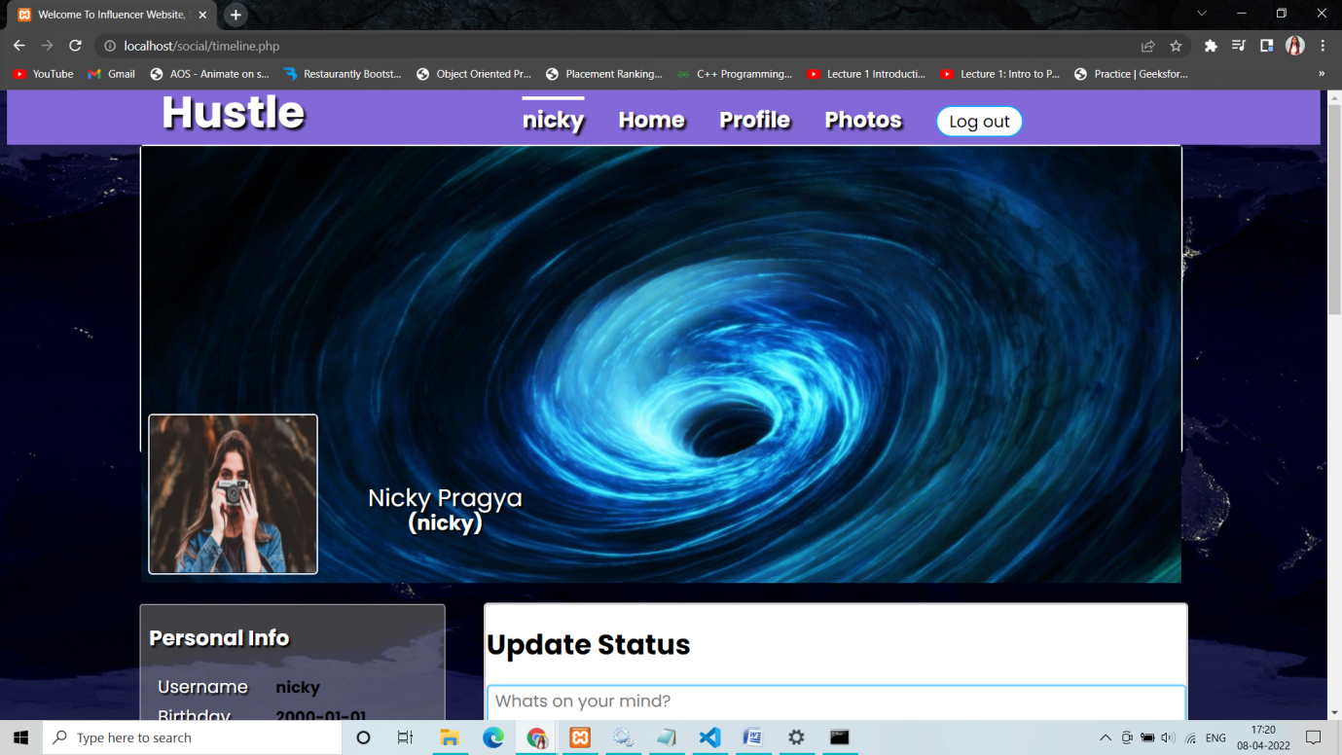

**4.6 Profile Page**

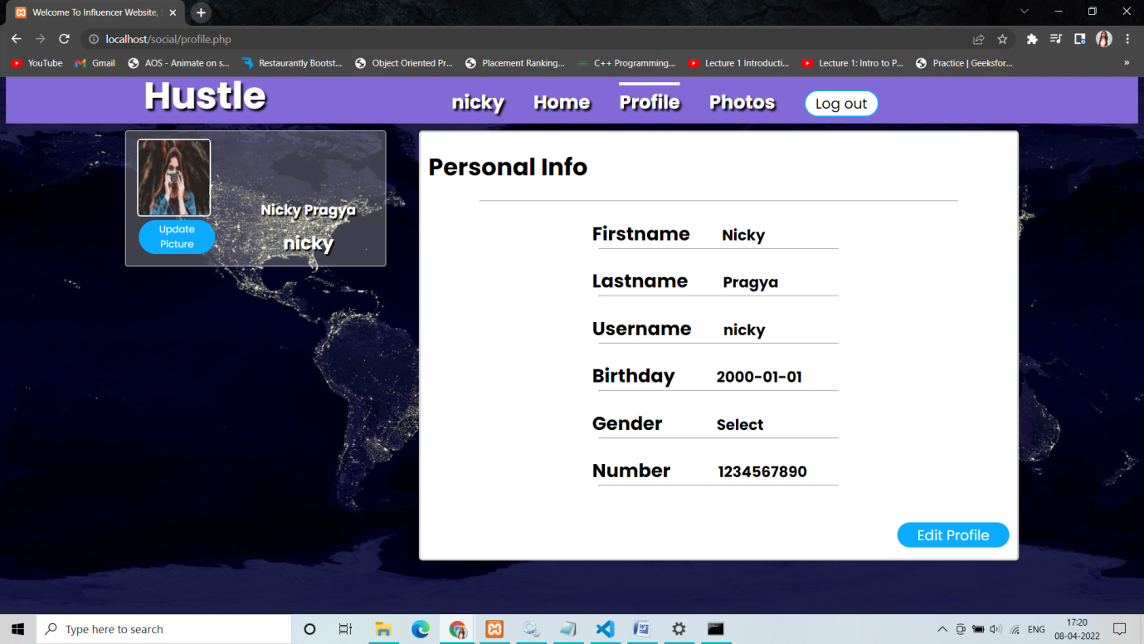

**4.7 Photos**

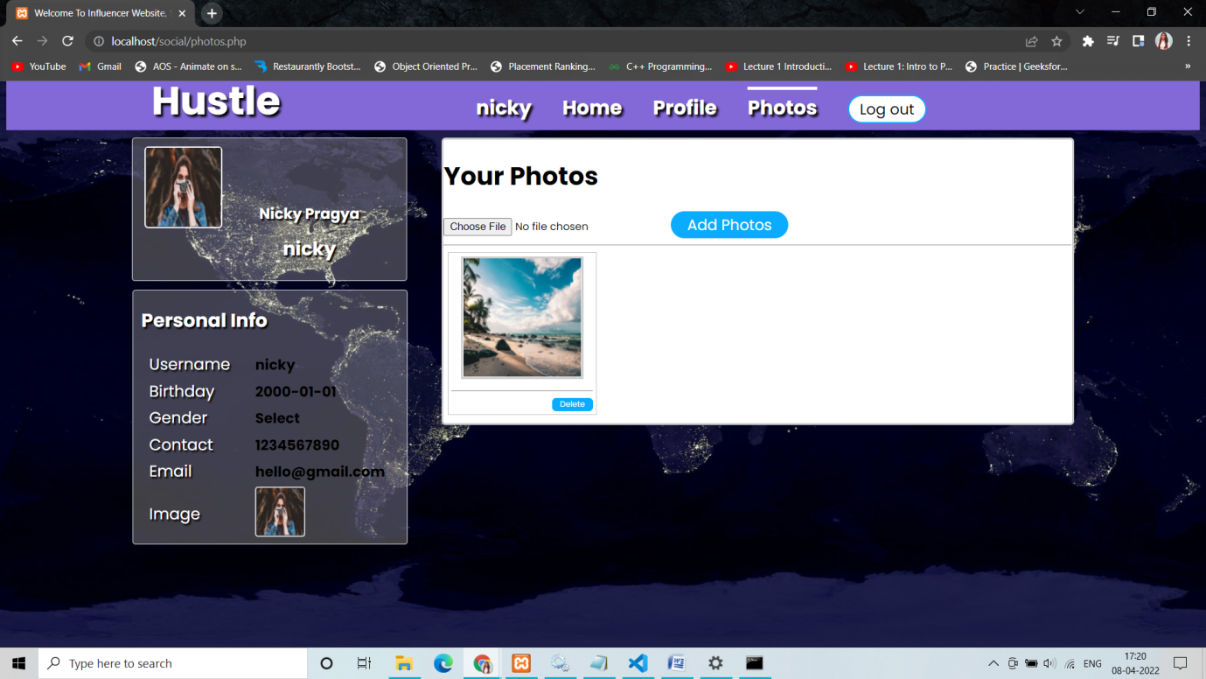

**4.8 Edit Profile**

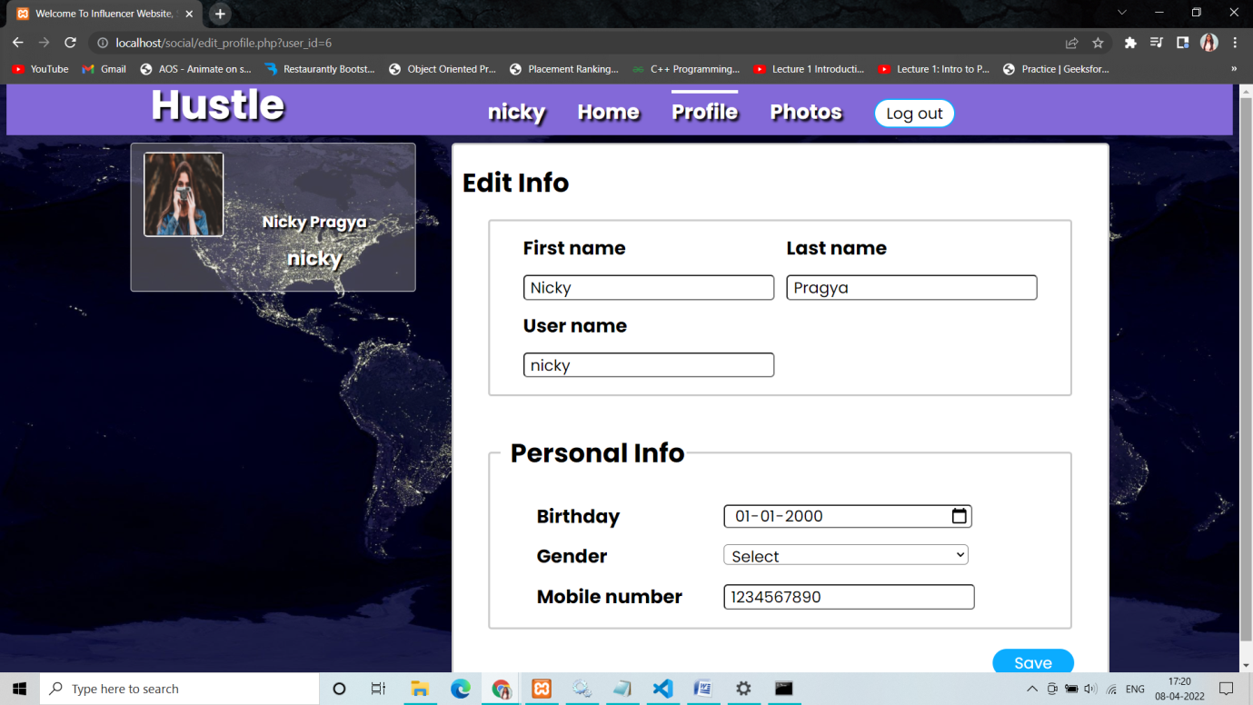

**CHAPTER 5**

**GitHub Link**

* **https://github.com/Pragya-10/PHP-Project-CA2**

**REFERENCES**

* [**https://www.php.net/docs.php**](https://www.php.net/docs.php)
* [**https://getbootstrap.com/**](https://getbootstrap.com/)
* [**https://developer.mozilla.org/en-US/docs/Web/JavaScript**](https://developer.mozilla.org/en-US/docs/Web/JavaScript)
* [**https://www.pexels.com/**](https://www.pexels.com/)

|  |
| --- |
|  |